MATERNELLE ST JOSEPH
MARCH 2020

DEVOTION SONGS

Happy all the time
https://www.youtube.com/watch?v=hHzofkZjEvc

Deep and wide
https://www.youtube.com/watch?v=wC89Aogk_FM

Read your Bible
https://www.youtube.com/watch?v=PYRyJxs9CG4

HELLO SONG
https://www.youtube.com/watch?v=tVlcKp3bWH8

Electric colours
https://www.youtube.com/watch?v=BKnE7IDQLc
Colours song
https://www.youtube.com/watch?v=wPcrhBAxvFI

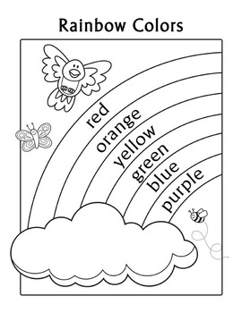

GOODBYE SONG

https://www.youtube.com/watch?v=Xcws7UWWDEs

